# Create the Monthly OLA Breached Report Procedure

Continuous Performance Enablement

**Purpose**

The Monthly OLA Breached Report is generated on the second business day of the month and posted to SharePoint. The information found in the report is from the OLA Dashboard.

**Related Policy**

* [IT Service Management Policy](https://sharepoint.jackson.com/sites/integrity/_layouts/15/WopiFrame.aspx?sourcedoc=%7be34fe42a-654a-469a-9d38-6612f00486dc%7d&action=view)

**Audience**

The following groups are responsible for adhering to this document:

* Continuous Performance Enablement

**Procedure**

|  |  |  |  |
| --- | --- | --- | --- |
| Step | | Action | |
| 1 | Access the “Monthly JTS Incident Tickets OLA Report” dashboard.   1. Connect to Remedy at <https://remedy.jacksonnational.com/arsys> 2. Click the “Applications” tab on the side of the screen. 3. Select “Smart Reporting”. 4. Select “Smart Reporting Console”. 5. Select the “Service Delivery Folder”      1. Select the “Service Level Management Folder”      1. Locate the “Monthly JTS Incident Tickets OLA Report” dashboard and double click on it.      1. When the dashboard opens, click the orange arrow next to the dashboards title tab:      1. Select “Export” from the drop-down list.      1. Click the arrow and select “PDF”. 2. Select “Landscape” 3. Click the “Export” button.      1. A rotating circle will appear at the Dashboard tab while the report is being created.      1. Select “Open” 2. Click “File” at the top of the screen 3. Select “Save as” 4. Save the report to the following location:   [O:\Service Delivery\Service Level Management\Reporting\YYYY\Monthly OLA Breached Reports\YYYY\Monthly OLA Breached Report](\\\\jacksonnational.com\\GROUP\\ITVOL1\\VOL1\\group\\PM COE\\Forecasting & Metrics Model Rollout\\SLA Reporting\\Reporting)   1. Repeat h) and i) 2. Click the arrow and select “XLSX”. This version of the report will take several minutes to create. 3. Repeat n) through q).   ***Note:*** *The information from the summary (page 2) will be used for the KPI Monthly Status Report (see* ***Appendix A).***  For more information see:  [Create the Monthly KPI Status Report Procedure](../SLA%20Reporting%20Procedures/Create%20the%20Monthly%20KPI%20Status%20Report.docx) | |
| 2 | Post the PDF and XLSX version of the Monthly OLA Breached Report to SharePoint:   1. Access the Monthly Production OLA Breached Report folder at the following location on SharePoint:   [Monthly Reporting\SLM\Monthly Production OLA Breached Report\YYYY](http://docs.jackson.local/it/sites/rs/Monthly%20Reporting/Forms/current.aspx?RootFolder=%2Fit%2Fsites%2Frs%2FMonthly%20Reporting%2FSLM%2FMonthly%20Production%20OLA%20Breached%20Report&FolderCTID=0x0120008757BF0A693734429A00C5DB64BC5778&View=%7B240B9B17%2D0630%2D4691%2DAA51%2DE27EC38CF00E%7D)   1. Select the correct year. 2. Click the “Upload” icon near the top of the screen. 3. Click the “Browse” button and navigate to the location of the reports (see Step 1 / q). 4. Select the pdf file. 5. Click the “OK” button. 6. Click the “Save” button. 7. Repeat c) through d) 8. Select the xls file. 9. Repeat f) through g). | |
| 3 | Run the Monthly JTS Breached Ticket Detail by Breach Type:   1. Repeat Step 1 a) through f). 2. Locate the Monthly JTS Breached Ticket Detail by Breach Type report and double click it.      1. Click the “Publish” button near the top of the screen.      1. Select “Export to PDF”. 2. Ensure that “Landscape” is checked. 3. Click the “Export” button. 4. A rotating circle will appear at the Dashboard tab while the report is being created.      1. Select “Open” 2. Click “File” at the top of the screen 3. Select “Save as” 4. Save the report to the following as “Monthly Totals by Priority MM YYYY: at the following location:   [\\jacksonnational.com\GROUP\ITVOL1\VOL1\group\PM COE\Forecasting & Metrics Model Rollout\SLA Reporting\Reporting\YYYY\Monthly OLA Breached Reports\Calculated for KPI](%20\\jacksonnational.com\GROUP\ITVOL1\VOL1\group\PM%20COE\Forecasting%20&%20Metrics%20Model%20Rollout\SLA%20Reporting\Reporting\YYYY\Monthly%20OLA%20Breached%20Reports\Calculated%20for%20KPI%20)  ***Note:*** *The total number of “Assignment” OLA Tickets breached and the number of “Resolution” OLA tickets breached will be used on the KPI Report (see Appendix B).*  For more information see:  [Create the Monthly KPI Status Report Procedure](../SLA%20Reporting%20Procedures/Create%20the%20Monthly%20KPI%20Status%20Report.docx) | |

**Appendix A**

The numbers in the bottom row of the summary will be used in the KPI Report.

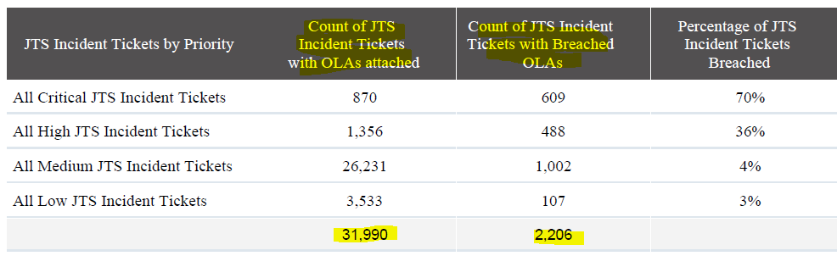

**Appendix B**

The “Assignment” and “Resolution” totals for each priority (Critical, High, Medium, and Low) will be used in the KPI Report.





**Modification**

The following associates can make modifications to this document:

* Director, Continuous Performance Enablement
* Vice President, Continuous Performance Enablement
* Chief Technology Officer, JET
* Chief Technology Officer, PGDS

|  |  |
| --- | --- |
| Continuous Performance Enablement Process | |
| Responsible Party: CPE Metrics Approving Authority: Bali Bodeddula, Director, JET Continuous Performance Enablement | Date Created: 12/06/2018 Last Modified:  Last Reviewed: |